The National Archives - DROID 5

Technical Architecture

Author: Richard Flitcroft, Alok Dash

Date: 02 December 2009-12-02
Version: 0.1
Status: Draft

Table of Contents

1 Introduction 3
2 Design Constraints 3
3 Service Component Summary 3
3.1 Profile Database Service 3
3.2 Identification Engine 3
3.3 Resource Submitter 3
3.4 Result Handler 3
3.5 Profile Manager 3
4 Archive Unpacker 4
4.1 Profile Specification Manager 4
4.2 Signature Manager 4
5 Entity Component Summary 4
5.1 Resource Wrapper 4
5.2 Profile Specification 4
5.3 Profile Instance 4
6 Service Component Interaction Diagram 5

Introduction
This document gives an architectural overview of the DROID 5 application. The architecture is a loosely-coupled service orientated design. The application is comprised of a configuration (or “wiring-up”) of these services. The services communicate using defined entities

Design Constraints
The identification engine component of the DROID application must be an embeddable API which has no dependencies on external components or their APIs. This is to facilitate the embedding of DROIDs identification algorithms inside another application.

The DROID application must be usable via a GUI, the command line, or as a java API.

Service Component Summary
These components act as stateless services

Profile Database Service
The profile database service is a service which interacts with an embedded relational database containing a profile specification and the results of identifications which have been made. A profile database cannot be modified once it is complete - a profile database becomes read-only once the identification processes have terminated.

Identification Engine
This is a component which is responsible for identifying a file format given a reference to a binary resource. It uses various techniques to identify file formats:
- File extension
- Binary signature match
- Text heuristics match

The identification engine will accept identification jobs asynchronously, and deliver each identification result to any registered Result Handlers.

Resource Submitter
This component submits a resource wrapper for each resource specified in a Profile Specification to the identification engine.

Result Handler
These components are invokes whenever the identification engine finished its identification. Result Handlers may add the result to the profile instance, or trigger further submissions - for example if the identification engine identified an archive files such as a compressed file or set of files in zip, tar, gzip, bzip format etc.

Profile Manager
This component is responsible for all profile management operations:
- Create a new profile instance –creates a new profile instance together with its associated database.
- Load profile instance – loads an existing profile instance given the path to the database in which it is contained.
- Pause – pauses the profile specified so that all submission and result handling is suspended
- Resume – resumes a paused profile
- Cancel – cancels a running profile and marks is as cancelled.

Archive Unpacker
Responsible for unpacking archive files.

Profile Specification Manager
This component manages profile specifications so that they may be created, modified, imported and exported in XML format, and persisted across instances of the DROID application.

Signature Manager
Provides signature management functionality such as signature updates, bespoke signature creation, signature set definition.

Reports manager
Generates CSV and/or XML reports based on a profile or multiple profiles.

Entity Component Summary
These components represent entities which encapsulate the stateful data and behaviour of the DROID application. They are used by the service components to communicate.

Resource Wrapper
This component encapsulates a binary resource and any meta-data such as its name, location, size and created date etc. and allows random access to the resource’s binary data.

Profile Specification
A profile specification is a set of locations that will be used when a profile is executed.
Typically, this may comprise of specific file paths, directory paths and remote URLs containing binary resources. Directory paths may be specified as recursive’ i.e. the resource specified includes any nested files and directories.

Profile Instance
A profile instance represents the identification jobs and their results for a given profile specification.

Service Component Interaction Diagram
Identification Engine
Profile Spec Resource Submitter
Profile Manager
Storage Result Handler
Profile Database Service
Archive File Submitter
Profile Specification Manager
Archive File Result Handler
Result Queue
Signature Manager
Reports Manager

Data Models

Profile Instance Data Model
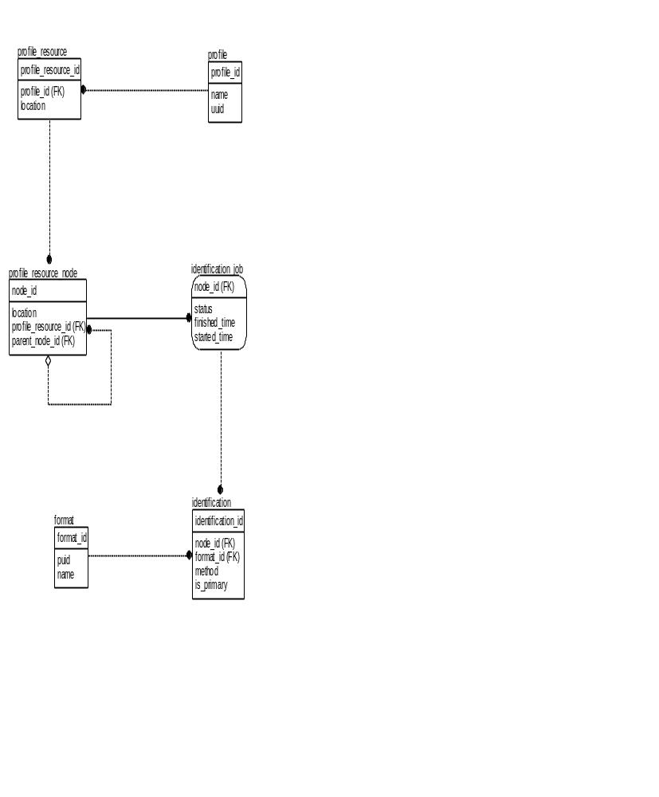

Profile Specification Data Model
